**Supplementary Information**

The Metabolome Weakens RNA Thermodynamic Stability and   
Strengthens RNA Chemical Stability

Jacob P. Sieg1,2, Lauren N. McKinley1,2, Melanie J. Huot3,4, Neela H. Yennawar5,  
 and Philip C. Bevilacqua*1,2,3

1Department of Chemistry, Pennsylvania State University, University Park, PA 16802.

2Center for RNA Molecular Biology, Pennsylvania State University, University Park, PA 16802.

3Department of Biochemistry and Molecular Biology, Pennsylvania State University, University Park, PA 16802.

4Department of Biology, Pennsylvania State University, University Park, PA 16802.

5The Huck Institutes of the Life Sciences, The Pennsylvania State University, University Park, PA 16802.

**Keywords**

Magnesium ion, Metabolites, Chelated magnesium, RNA folding, RNA function, Near-cellular condition

**ORCID:**

Jacob P. Sieg: 0000-0001-5414-1667

Lauren McKinley: 0000-0002-3937-3811

Melanie Huot: 0000-0002-6669-2244

Neela H. Yennawar:0000-0001-7278-659X

Philip C. Bevilacqua: 0000-0001-8074-3434

*Corresponding author

Contents

Supplementary information methods 3

Reagent preparation 3

Data analysis, transparency, and reproducibility 3

Apparent Mg2+ binding constant determination with isothermal titration calorimetry 3

Determination of Mg2+ speciation with HQS fluorescence 3

Apparent Mg2+ binding constant determination with HQS 4

Determination of the total Mg2+ required to have 2 mM free Mg2+ in artificial cytoplasm 4

Artificial cytoplasm preparation 5

Single-binding-site statistical model for Mg2+ speciation in artificial cytoplasm 5

Fluorescence-detected binding isotherms 7

Fluorescence-detected binding isotherm data analysis 7

MeltR concentration optimization algorithm 9

Helix folding energy error analysis 10

RNA transcription and purification 11

Small angle x-ray scattering (SAXS) 12

Supplementary information figures 14

SI Figure 1 14

SI Figure 2 15

SI Figure 3 16

SI Figure 4 16

SI Figure 5 17

SI Figure 6 17

SI Figure 7 18

SI Figure 8 19

SI Figure 9 20

SI Figure 10 21

SI Figure 11 22

SI Figure 12 23

SI Figure 13 24

Supplementary information tables 25

SI Table 1 25

SI Table 2 26

SI Table 3 26

SI Table 4 26

SI Table 5 27

SI Table 6 29

SI Table 7 30

# Supplementary information methods

## Reagent preparation

Buffers were prepared by dissolving salts in purified (18 MΩ*cm) water in volumetric flasks, at the purity specified in supplementary information (SI) table 1. All reagents contained a background of 20 mM MOPS, 0.01 mM EDTA, 0.001% (w/v) SDS (pH 7) buffer unless otherwise stated. Small amounts of EDTA were present to sequester trace divalent metal ion contamination. Small amounts of SDS were present to prevent RNA from sticking to tubes/pipette tips and to protect RNA from enzymatic degradation. To ensure accurate magnesium chloride concentrations, solutions were prepared by diluting standard 1.00 (±0.01) M magnesium chloride solution from Sigma into buffer, or magnesium chloride hexahydrate was dissolved in buffer and then the concentration was determined with atomic absorption spectroscopy.

## Data analysis, transparency, and reproducibility

Data analysis was performed in R (v4.1.2; R Core Team 2021) with the *tidyverse* package (v1.1.1; Wickham et al. 2019) for data wrangling and plotting. Unless otherwise stated, non-linear regression was performed with the *nls* function and linear regression was performed with the *lm* function in base R.The packages *MuMIn* (v1.46.0; Kamil Barton 2022)*,* *ggpubr* (v0.4.0; Alboukadel Kassambara 2020), *viridis* (v0.6.2; Simon Garnier, Noam Ross, Robert Rudis, Antônio P. Camargo, Marco Sciaini, and Cédric Scherer 2021), *ggbeeswarm* (v0.6.0; Erik Clarke and Scott Sherrill-Mix 2017), and *cowplot* (v1.1.1; Claus O. Wilke 2020)were used to evaluate polynomial fits, display statistics, generate color-blind-friendly palettes, make beeswarm plots, and arrange figure panels, respectively. Secondary structures were drawn with R2easyR (https://github.com/JPSieg/R2easyR) and R2R.1 All raw data and analysis code is available with instructions for reconstitution on any console at (<https://github.com/JPSieg/JPSiegMetaboMetaloRNA>).

## Apparent Mg2+ binding constant determination with isothermal titration calorimetry

Samples were degassed using a ThermoVac (MicroCal, LLC) degasser before loading into a VP-ITC MicroCalorimeter (MicroCal, LLC) according to the manufacturer’s recommendations, with pure (18 MΩ*cm) water in the reference cell. Titration was performed with a 10 µcal/sec reference power and a stirring speed of 310 rpm. Twenty-nine injections (one 2 μL injection followed by twenty-eight 10 μL injections) were performed in total at an injection rate of 0.5 μL/sec with a 150 sec equilibration period following each injection. The first injection was not included in subsequent analysis. Data were analyzed using ITC parsing and non-linear regression fitting functions in MetaboMgITC (<https://github.com/JPSieg/MetaboMgITC>).2

## Determination of Mg2+ speciation with HQS fluorescence

8-Hydroxy-5-quinolinesulfonic (HQS) acid hydrate (98% purity) was purchased from Sigma Aldrich and recrystallized in water 10 times to remove trace metal contamination, as per reference 3. Purified HQS was dissolved in buffer to a stock concentration of 100 mM (determined with UV absorbance using ε326 nm = 2600 M-1cm-1). HQS was then diluted to a final concentration of 50 μM with variable concentrations of Mg2+ and metabolites with a final sample volume of 100 µL. Control samples contained 240 mM NaCl and 140 mM KCl.

HQS emission was measured with a Biotek Cytation 3 plate reader with an excitation of 355 nm and emission of 500 nm. Plates were sealed with transparent PCR film and were incubated at 37 °C for 10 min prior to reading to ensure thermal equilibration.

Fluorescence data in the absence of metabolite chelators were fit to Equation 1, in order to determine the inverse molar apparent association constant for HQS binding to Mg2+  (KHQS).

[Mg] is the free Mg2+ concentration in the sample, which is equal to the total concentration of magnesium chloride in the absence of chelators. Fmax and Fmin are the intensities of the Mg2+-HQS complex and free HQS, respectively. The fluorescence for all samples was normalized using Fmax and Fmin to produce a normalized fluorescence intensity Fnorm.

Free Mg2+ concentrations for each sample were calculated with Equation 3, using Fnorm and KHQS.

## Apparent Mg2+ binding constant determination with HQS

Metabolite concentrations are provided in the legend of SI Figure 2 for HQS experiments to determine apparent binding constants, and extra NaCl or KCl was added to maintain a constant total monovalent metal ion concentration of 240 mM Na+ and 140 mM K+. Metabolite solutions were treated with Chelex resin (Sigma) to remove divalent ion contamination. The solution was passed through a 0.2 µm filter and the pH was readjusted to 7.0. The free Mg2+ concentration in the presence of chelators versus the total Mg2+ was fit to Equation 4 to obtain K´.

$$[Mg]= {[Mg]}_{T}-\frac{\left( {[Mg]}_{T}+ {[L]}_{T}+ \frac{1}{K'}\right)±\sqrt{{\left( {[Mg]}_{T}+ {[L]}_{T}+ \frac{1}{K'}\right)}^{2}-4{[Mg]}_{T}{[L]}_{T}}}{2} (4)$$

Where ${[Mg]}_{T}$ is the total Mg2+ concentration, ${\left[L\right]}_{T}$ is the metabolite concentration, and $K'$ is the apparent ligand binding constant for Mg2+, represented by Equation 5.

$$K^{'}=\frac{[MgL]}{[Mg][L]} (5)$$

## Determination of the total Mg2+ required to have 2 mM free Mg2+ in artificial cytoplasm

The total Mg2+ concentration required to have 2 mM free Mg2+ in artificial cytoplasm was approximated using the free Mg2+ concentrations calculated with HQS data. The free Mg2+ concentration, which was measured as a function of the total Mg2+, was fit to 1st, 2nd, 3rd, 4th , 5th , 6th, 7th, 8th, 9th and 10th order polynomials in the form:

$$[Mg]= \sum_{i=1}^{N}{A_{i}{{[Mg]}_{T}}^{i}}+ C (6)$$

Where *N* is the order of the polynomial and *A/C* are constants determined by linear regression. Fit polynomials were evaluated by calculating the Akaike information criterion (AIC), in order to determine which polynomial best described the data using the minimum number of terms. The polynomial with the lowest AIC was then solved numerically to calculate the total Mg2+ required to generate 2 mM free Mg2+ in the presence of metabolites, with a tolerance of 0.01 mM. The fluorescence of control samples containing the no added MgCl2 condition was compared to 10 mM EDTA to determine divalent metal ion contamination levels in artificial cytoplasm.

## Artificial cytoplasm preparation

Artificial cytoplasm was prepared to maintain a final monovalent ion concentration of 240 mM Na+ and 140 mM K+ and a final pH of 7.0. First, metabolite salts or solutions were dissolved or diluted into water in volumetric flasks. Second, the pH of each solution was adjusted to 7.0 using 10 M NaOH. The amount of Na+ or K+ added with each component was recorded. Third, 5 M NaCl and 2 M KCl were added for a final Na+ and K+ concentration of 480 mM and 280 mM, respectively. Then, the volumetric flask was filled with water to 10 mL. Lastly, a test quantity of the 2x solution was diluted to a 1x concentration and the pH was tested with a VWR Symphony pH probe. The 2x concentrated artificial cytoplasm was aliquoted and stored at -20 °C. A detailed protocol for the Eco80 artificial cytoplasm is available in SI Table 1. Periodically, the artificial cytoplasm was spot checked for NTP degradation using thin-layer chromatography on PEI-Cellulose F plates (Supelco) developed with a 0.3 M potassium phosphate pH 7.0 mobile phase.4

## Single-binding-site statistical model for Mg2+ speciation in artificial cytoplasm

We used a statistical model, that considers experimental errors in metabolite concentrations and uncertainties in apparent binding constant determination, to calculate the expected free Mg2+ concentration in artificial cytoplasm, assuming single-site binding (meaning one metabolite molecule binds one Mg2+ and vice-versa). Single-site binding of a metabolite to Mg2+ is described by the apparent dissociation constant (KD´).

Rearranging to determine the concentration of the metabolite-ligand complex [MgL] as a function of the concentration of free Mg2+, and the total ligand concentration (${\left[L\right]}_{T}$), we get equation 8.5

In a mixture of metabolites, the total Mg2+ will be the free Mg2+, plus the Mg2+ bound by different metabolites.

$${\left[Mg\right]}_{T}= [Mg]+\sum_{i=1}^{N}{\left[MgL_{i}\right] \left(9\right)}$$

N is the total number of metabolites in the solution. Equation 8 was plugged into Equation 9 to obtain the total Mg2+ as a function of the free Mg2+, the apparent dissociation constant, and the metabolite concentration.

$${\left[Mg\right]}_{T}= [Mg]+\sum_{i=1}^{N}{\frac{{\left[L_{i}\right]}_{T}[Mg]}{{K_{D}^{'}}_{i}+ [Mg]} \left(10\right)}$$

The total Mg2+ and the total metabolite concentrations are set in the experiment, and the apparent dissociation constants were determined with ITC or HQS fluorescence. Thus, the expected free Mg2+ was determined to a precision of 0.01 mM by solving equation 10 numerically (possible because equation 10 has one real solution between 0 free Mg2+ and the total Mg2+ concentration in the solution).

Expected experimental error was calculated by propagating uncertainties in mass and volume during sample preparation. Briefly, equation 11 and 12 was used for propagation of uncertainty for addition and multiplication/division respectively.

$$For A=B+C or B-C \left\{δA= \sqrt{{δB}^{2}+{δC}^{2}}\right\} (11)$$

$$For A=B*C or A= \frac{B}{C} \left\{δA= A\sqrt{{\left(\frac{δB}{B}\right)}^{2}+{\left(\frac{δC}{C}\right)}^{2}}\right\} (12)$$

The percent impurities (supplied by the chemical vendor) were used as the uncertainty for mass measurements because the uncertainty from the impurity was greater than the precision of the analytical balance (0.1 mg). Volume uncertainties were provided by the manufactures of the pipettes and volumetric flasks. For metabolites, uncertainty in concentration was on average   
9.1% of the final concentration in artificial cytoplasm. Thus, we used 10% uncertainty for metabolite concentrations.

For the statistical model, random error was seeded into equation 10 using the *rnorm* function in base R, which creates random error based on a gaussian distribution with a standard deviation ($σ_{x})$ described by equation 13.

$$σ_{x}= \frac{\%uncertainty}{100\%}x (13)$$

The standard deviation provided by the fit was used for apparent dissociation constants. Thus, Equation 14 can be used to generate a virtual artificial cytoplasm with realistic errors in reagent concentrations.

$${\left[Mg\right]}_{T}+rnorm\left(σ_{{\left[Mg\right]}_{T}}\right)= [Mg]+\sum_{i=1}^{N}{\frac{\left({\left[L_{i}\right]}_{T}+rnorm\left(σ_{{\left[L_{i}\right]}_{T}}\right)\right)[Mg]}{{K_{D}^{'}}_{i}+rnorm\left(σ_{{K_{D}^{'}}_{i}}\right)+ [Mg]} \left(14\right)}$$

One thousand virtual artificial cytoplasm were created with Equation 14 to fully explore possible variance and the results were compared with experimental measurements of free Mg2+ determined with HQS.

## Fluorescence-detected binding isotherms

5´-FAM and 3´-BHQ1 labeled RNA were ordered from Integrated DNA Technology (IDT) and HPLC purified by IDT or in-house. For in-house HPLC, RNA peaks were manually collected on a Water’s AQUINITY Arc UPLC system equipped with a Waters Xbridge C18 2.3 μm 4.6x150 mm column. 5 nmole of RNA was injected on a 60 °C preheated column and separated for 5 min with 100% 0.1 M aqueous triethylamine acetate (TEAA), followed by a 25 min transition to 100% 0.1 M TEAA 20% acetonitrile, followed by 5 min of 100% 0.1 M TEAA 20% acetonitrile, and then a 5 min transition back to 100% aqueous 0.1 M TEAA, at a flow rate of 1 mL/min. Samples were dried under vacuum and resuspended in buffer. Then, samples were dialyzed twice against 1 L of buffer in an 8 well Life Technologies Microdialysis System equipped with a 1 kDa dialysis membrane (SpectraPore) for 24 h per liter of buffer. Concentrations of dialyzed RNA were determined using the absorbance at 260 nm and extinction coefficients provided by IDT. Final samples were prepared in triplicate, where FAM-RNA were diluted to 200 nM and BHQ1-RNA were diluted to 0, 1, 10, 50, 100, 150, 200, 400, 800, and 1000 nM (SI Figure 3). The 2x concentrated salts or artificial cytoplasm were diluted into the same samples to achieve a final 1x concentration with 0.5 mM free ROX as a passive reference dye. Samples were heated to 90 °C for 1.5 min, cooled at room temperature for 20 min, transferred into a 96 well qPCR plate, sealed with transparent qPCR film, and centrifuged for 2 min to remove air bubbles. Fluorescence emission of the entire plate as a function of temperature was measured using an Applied Biosystems Step 1 Plus qPCR instrument. Samples were heated from 20 to 80 °C at a ramp rate of 0.5 °C per minute, recording fluorescence at 0.5 °C increments. ROX-normalized FAM emission was exported from the Applied Biosystems software to a flat text file.

## Fluorescence-detected binding isotherm data analysis

Fluorescence-detected binding isotherms were fit using the *meltR.F* program in the MeltR package V0.9. MeltR performs the following data preprocessing steps before fitting:

1.) The fluorophore labeled strand concentration is optimized using the concentration optimization algorithm, described in detail below.

2.) Isotherms are fit to Equation 15 to determine KD and error in the KD at each temperature using "nls" in base R.

$$F=F_{max}+\left(F_{min}-F_{max}\right)\frac{\left(K_{D}+{[F]}_{T}+{[Q]}_{T}\right)-\sqrt{{\left(K_{D}+{[F]}_{T}+{[Q]}_{T}\right)}^{2}-4{[F]}_{T}{[Q]}_{T}}}{2{[F]}_{T}} (15)$$

where F is the observed fluorescence emission, Fmax is the fluorescence emission of the unbound fluorophore-labeled RNA strand, Fmin is the fluorescence emission of the fluorophore-labeled RNA strand bound to the quencher-labeled RNA strand, [F]T is the total fluorophore-labeled RNA strand concentration, [Q]T is the total quencher-labeled RNA strand concentration, and KD is the dissociation constant given by Equation 16.

$$K_{D}=\frac{\left[F\right]\left[Q\right]}{\left[FQ\right]} (16)$$

[F] is the concentration of free fluorophore-labeled RNA, [Q] is the concentration for free quencher-labeled RNA, and [FQ] is the concentration of the helical complex. Initial values for Fmax and Fmin are estimated by taking the mean of the 20% highest readings in each isotherm and the 20% lowest readings, respectively. Initial values for the KD are provided by the user, by default 0.1 nM.

3.) KDs are filtered by magnitude and error, according to user specifications, to determine which isotherms are most reliable. First, KDs outside of a user-specified range (10 to 1000 nM by default) are thrown out. Second, KDs are ranked by the error in the KD. KDs whose errors are above a user-specified error quantile are thrown out. The default KD error quantile is 0.25, meaning the algorithm will keep the 25% most accurate KDs, after filtering by magnitude (Filtering is discussed in more detail below).

4.) The most reliable KDs and temperatures are passed to Method 1 to make Van't Hoff plots and to calculate helix formation energies.

5.) Fluorescence data that produce reliable KDs are passed to Method 2 for global fitting and to calculate helix formation energies.

Method 1 fits a Van’t Hoff plot to Equation 17 to determine the enthalpy and entropy of folding.

$$lnK= \frac{∆S´}{R}-\frac{∆H´}{RT} (17)$$

Where ΔS´ is the entropy of helix dissociation, ΔH´ is the enthalpy of helix dissociation, R is the gas constant, and T is the temperature in Kelvin.

Method 2 globally fits raw fluorescence data to equation 18, produced by plugging equation 17 into equation 15 to determine the entropy and enthalpy of folding.

$$F={F_{max}}^{i}+\left({F_{min}}^{i}-{F_{max}}^{i}\right)∙$$

$$\frac{\left(e^{\left(\frac{∆S´}{R}-\frac{∆H´}{RT}\right)}+{[F]}_{T}+{[Q]}_{T}\right)-\sqrt{{\left(e^{\left(\frac{∆S´}{R}-\frac{∆H´}{RT}\right)}+{[F]}_{T}+{[Q]}_{T}\right)}^{2}-4{[F]}_{T}{[Q]}_{T}}}{2{[F]}_{T}} (18)$$

“*i”* is the reading when the data was collected, meaning that the Fmax and Fmin can float between readings but the ΔS´ and ΔH´ are required to be the same for all readings.

Helix folding energies are traditionally reported in terms of the association constant.

$$K=\frac{1}{K_{D}}=\frac{\left[FQ\right]}{\left[F\right]\left[Q\right]} (19)$$

Thus, the entropy and enthalpy of helix association, ΔS° and ΔH°, are obtained by inverting the algebraic sign on ΔS´ and ΔH´.

MeltR reports standard error (SE) estimates provided by the non-linear model generated with the *nls* function in base R. The Gibbs free energy of helix association at 37 °C (ΔG°37) is calculated with Equation 20.

$${{∆G}^{o}}_{37}=∆H°-310.15∆S° (20)$$

Error in the ΔG°37 of helix association was calculated with Equation 21.

$$σ_{{{∆G}^{o}}_{37}}=\sqrt{{σ_{∆H°}}^{2}+{\left({310.15σ}_{∆S°}\right)}^{2}-620.3\frac{σ_{∆H°,∆S°}}{∆H°∆S°}} (21)$$

Where σΔH,ΔS is the covariation between the ΔS° and ΔH° given by *nls* in base R. Additional error analysis is described below.6

## MeltR concentration optimization algorithm

We found that helix energies from fitting fluorescence-detected binding isotherms were highly dependent on errors in the determination of RNA concentrations in stock solutions, which is propagated systematically during sample preparation. For example, if the FAM-RNA stock was actually 20% more concentrated than the estimate calculated using UV absorbance and extinction coefficients, the FAM-RNA concentration in the final samples would be consistently 20% higher because the same amount of master mix was added to each sample (SI Figure 3). This can bias the resulting helix folding energies.

To understand why, we modeled data assuming a ΔH°, ΔS°, and ΔG°37 of -56.2 kcal/mol, -136.4 cal/mol/K, and -13.9 kcal/mol respectively, 5% random fluorescence error, and perfectly accurate determination of RNA concentrations in concentrated stocks (a 200 nM FAM-RNA concentration, and 0, 1, 10, 50, 100, 150, 200, 250, 400, 600, 800, and 1000 nM RNA-BHQ1 concentrations). We then used MeltR to fit the modeled data, resulting in a very accurate determination of ΔH = ‑56.0 kcal/mol, ΔS = -135.7 cal/mol/K, and ΔG°37 = -13.9 kcal/mol. We next considered how assuming incorrect RNA stock concentrations, thus incorporating a systematic error, could affect the accuracy of the fits. Systematic error (-50% to +50%) was seeded into virtual stock concentrations and the data were refit (SI Figure 12A). We found that fit accuracy was highly dependent on error in stock concentrations. For example, if the FAM-RNA concentration in the stock was 25% lower than the estimate, and the RNA-BHQ1 concentration was 25% higher than the estimate, the ΔG°37 that MeltR calculated was off by ~4 kcal/mol. Likewise, if the FAM-RNA concentration in the stock was 25% higher than the estimate, and the RNA-BHQ1 concentration is 25% lower than the estimate, the ΔG°37 that MeltR calculated was off by ~2.5 kcal/mol. However, if the FAM-RNA error and the RNA-BHQ1 error compensated each other, e.g. %RNA-BHQ1 error = %FAM-RNA error, the ΔG°37 that MeltR calculated was off by less than 0.2 kcal/mol, even with 50% inaccuracy in RNA stocks.

We next considered a more realistic scenario, where the experiment assumed perfectly accurate determination of RNA concentrations but there was actually +20% FAM-RNA concentration error. Data were modeled using the same folding energies and RNA-BHQ1 concentrations, but with a 240 nM FAM-RNA concentration (+20% error). We then used MeltR to fit the modeled data, assuming a 200 nM FAM-RNA concentration, resulting in inaccurate determination of ΔH° = -35.8 kcal/mol, ΔS° = -75.5 cal/mol/K, and ΔG°37 = -12.3 kcal/mol, a ΔG°37 error of 1.6 kcal/mol. Once again, we seeded systematic error (-50% to +50%) into virtual stock concentrations and the data were refit (SI Figure 12B). Similar to SI Figure 12A, we found that fit accuracy was highly dependent on errors in stock concentrations. However, the fits were most accurate according to Equation 22 instead of %RNA-BHQ1 error = %FAM-RNA error.

$${\%BHQ1}_{error}=\frac{1}{X}{\%FAM}_{error}+\frac{100-100X}{X} (22)$$

Where X is the actual FAM-RNA concentration divided by the estimated FAM-RNA concentration (240 nM/200 nM = 1.2 in this example). Thus, MeltR does not need perfectly accurate concentrations, just an optimization algorithm that finds the FAM-RNA concentration correction factor X. Note, %RNA-BHQ1 error = %FAM-RNA error is a special case of Equation 22, where X = 1.To find X, MeltR selects an isotherm (usually the lowest temperature), where the KD is more than 10 times less than the FAM-RNA labeled concentration (SI Figure 12C). At this KD range, the shape of the binding curve is independent of KD, and MeltR uses the isotherm as a Job plot to determine X. MeltR then uses X to correct the FAM-RNA concentration. In essence, the Job plot is like an active-site titration in that it finds the relative active amounts of two oligonucleotides, thereby correcting for errors in extinction coefficients and RNA integrity.7

We next tested the MeltR concentration optimization algorithm. The modeled data, with an uncorrected +20% FAM-RNA concentration error, were fit using MeltR with the concentration optimization algorithm on, resulting in an accurate determination of ΔH° = -51.9 kcal/mol, ΔS° = -123.5 cal/mol/K, and ΔG°37 = -13.6 kcal/mol, a ΔG°37 error = 0.3 kcal/mol. We then seeded additional error into the data set (-50% to +50%), refit the data using the MeltR concentration optimization algorithm, and found that MeltR calculates accurate folding energies (within 0.2 kcal/mol in terms of the ΔG°37 on average) even with large inaccuracies in reagent concentration estimates (SI Figure 12D).

MeltR then filters out isotherms that produce inaccurate KDs, according to user specifications (see above). Both the MeltR KD range and KD error threshold can be adjusted by the user in real time to refine fits by manually inspecting Van’t Hoff plots to identify the most accurate temperature range to fit. For example, the MeltR fit of the data that was modeled using +20% FAM-RNA concentration error can be improved to ΔH° = -56.4 kcal/mol, ΔS° = -136.9 cal/mol/K, and ΔG°37 = -13.9 kcal/mol using the concentration optimization algorithm and by selecting the most accurate temperature range by inspecting the Van’t Hoff plot.

## Helix folding energy error analysis

MeltR reports standard errors propagated from the fit, which reflect the precision of the parameters and can be treated statistically.6 However, the accuracy of such parameters is also dependent on systematic errors from instrument calibration, concentration estimates, RNA impurities, etc. These are more difficult to control for and treat statistically. Precision estimated from the fit for method 1 (see above) were 1.56%, 1.93%, and 0.27% uncertainty on average for the ΔHo, ΔSo, and ΔGo37 (SI Table 5). Method 2 was less precise, at 21.21%, 26.62%, and 3.61 % uncertainty on average for the ΔH°, ΔS°, and ΔG°37. However, the difference in helix folding energies between the two methods was much smaller, at 1.11%, 1.39%, and 0.12% on average for the ΔH°, ΔS°, and ΔG°37(SI Table 5). Given that the two methods provide similar helix folding energies, but different precisions, the discrepancy in standard error likely reflects differences in the number of parameters that must be estimated by the fit (two for method 1, ΔHo and ΔSo; 2+2*number of raw isotherms for method 2, ΔHo, ΔSo, and a Fmax/Fmin for each raw isotherm), more than accuracy in helix folding energy estimation. Turner and colleagues estimated that an uncertainty of 12%, 13.5%, and 4% for the ΔHo, ΔSo, and ΔGo37, respectively, conservatively reflects systematic and random errors for absorbance melting curves.6 Given that the discrepancy between method 1 and method 2 were smaller than the Turner uncertainty for all fluorescence-detected binding isotherms in this study, and that we are determining differences between conditions on the same sequences collected in the same lab, the 4% uncertainty in terms of the ΔGo37 may be too conservative. We determined that there was on average 0.2 kcal/mol, or 1.5%, error for MeltR fitting modeled fluorescence data using the concentration optimization algorithm (SI Figure 12). This deals with errors in RNA concentration estimates, an important source of systematic error. Thus, we reported the ΔGo37 of helix formation from method 1 with an uncertainty of 1.5% in Table 3 and Figure 2D.

## RNA transcription and purification

Yeast tRNAPhe was transcribed from 7 µM hemiduplex DNA and guanine aptamer/CPEB3 ribozymes were transcribed from primer extended duplexes prepared with polymerase chain reaction (PCR) reactions (Supplementary table 8).5,8,9 PCR was performed with Taq polymerase (New England Biolabs) and treated with an RNA clean and concentrate kit (Zymogen), according the manufacturer’s instructions. For cleaning up large scale PCR to make template for SAXS experiments, polymerase was removed with an equal volume 25:24:1 phenol:chloroform:isoamyl alcohol extraction, and two subsequent equal volume 24:1 chloroform:isoamyl alcohol extractions. The dNTPs were removed using an ethanol precipitation with ~2 M ammonium acetate and >75% ethanol. Transcription reactions were performed with in-house prepared T7 polymerase at 37 °C for 3 h, with 4 mM ATP, 4 mM CTP, 4 mM UTP, 8 mM GTP, 25 mM MgCl2, 0.1 mM spermidine, 2 mM DTT, and 20 mM Tris (pH 8.0). The NTP stocks were preadjusted to pH 8.0 with Tris base. Transcriptions were stopped with the addition of EDTA to a final concentration of 50 mM and treated using phenol:chloroform:isoamyl alcohol extractions (as described for the PCR) followed by ethanol precipitations containing ~2 M ammonium acetate and >75 % ethanol. RNA was resuspended in 50% formamide with 25 mM EDTA (pH 8.0), heated to 90 °C, and loaded hot onto a denaturing (8.3 M urea) 10% (g/mL) acrylamide gel containing 1x TBE. Full length RNA bands were identified with UV-shadowing, excised, and electroeluted (Elutrap, Whatman) according to the manufacture’s recommendation. Electroluted RNA was concentrated with an ethanol precipitation containing ~0.8 M LiCl and >75 % ethanol, resuspended in buffer, and stored at -20 °C.

For 5´-end labeling, the 5´-triphosphate on the transcription product was removed from ~10 pmol of RNA using shrimp alkaline phosphatase SAP (New England Biolabs). Subsequently, SAP was heat inactivated by incubating at 72 °C for 5 min. The RNA from the SAP reactions was 5´-32P labeled with 0.5 to 3.5 μM [γ-32P] ATP (PerkinElmer, 5 mCi) using T4 polynucleotide kinase (New England Biolabs) according to the manufacturer’s recommendation. Kinase reactions were stopped with an equal volume of 90% formamide with 50 mM EDTA (pH 8.0) loading dye containing trace xylene cyanol and bromophenol blue. Kinased products were excised from a denaturing (8.3 M urea) 10% (g/mL) acrylamide gel containing 1x TBE, crushed and soaked overnight in 1 mM EDTA, 250 mM NaCl, and 10 mM Tris (pH 7.5) at 4 °C, ethanol precipitated, and resuspended in 100 µL of buffer. For internal (body) labeling, RNA was transcribed with an additional 2 µL of [α-32P] ATP (Perkin Elmer, 250 µCi) and purified as described for the kinase reaction.

*In-line probing chemical degradation assay.*  For in-line probing (ILP) degradation assays, 5 to 10 kcpm/μL of 5´-32P labeled RNA was incubated in triplicate at 37 °C on a PCR block. Time points were taken at 0, 2, and 4 days by quenching 10 μL of reaction in 10 μL of 95% formamide containing 50 mM EDTA (pH 8.0) buffer with trace xylene cyanol and bromophenol blue. Then, 3 μL of sample was fractionated on a denaturing (8.3 M urea) 10% (g/mL) acrylamide gel containing 1x TBE. The gel was dried, exposed on a Phosphoimager cassette, and scanned with a Typhoon Phosphoimager. Gels images were quantified with SAFA10 three times to capture variance between quantifications. Time points were corrected for background degradation at each band by subtracting out the band intensity at time 0. The change in counts with time was determined by a simple linear fit at each band (y = mx + b), where the slope “m” is the change in counts with time.

## Small angle x-ray scattering (SAXS)

Transcribed and purified RNA was dialyzed twice against 1 L of buffer containing 2 mM MgCl2 in an 8-well Life Technologies Microdialysis System equipped with a 1 kDa dialysis membrane (SpectraPore) for 24 h per L of buffer. RNA was renatured at 80 °C for 1.5 min and cooled to room temperature for 20 min. Approximately 700 µg of RNA was fractionated on an Agilent 1260 Infinity II HPLC system equipped with a 100 Å pore 5 µm silica bead 7.8 x 300mm Wyatt SEC hydrophilic column at 4 °C to purify RNA in the monomer conformation, with the dialysis buffer as the mobile phase (0.5 mL/min). The correct molecular weight of monomers was confirmed using an in-line Wyatt Technology DAWN MALS and Wyatt Optilab Refractive Index (RI) detector. Monomers were then diluted to 100 µg/mL in artificial cytoplasm with Mg2+. The RNA was incubated at 37 °C for 1 h before SAXS data acquisition.

SAXS data was collected at 1.54 Å using a Rigaku MM007 rotating anode and a BioSAXS2000nano Kratky camera system. The system includes OptiSAXS confocal max-flux optics and a sensitive HyPix-3000 hybrid photon counting detector. The sample capillary-to-detector distance was 495.8 mm and was calibrated using silver behenate powder (The Gem Dugout, State College, PA). The RNA samples were loaded using an autosampler onto a quartz capillary flow cell mounted on a stage cooled to 4°C. The sample cell and full X-ray flight path, including beam stop, were kept *in vacuo* (< 1 mtorr) to eliminate air scatter. Data reduction including image integration, normalization, and background buffer data subtraction were performed with SAXSLAB software. Six ten-minute images from RNA and buffer samples were collected and averaged after ensuring that no X-ray radiation damage had occurred. This was followed by reference buffer subtraction to get the raw SAXS scattering curve from the RNA-only (SI Figure 7A).

The Guinier analysis and distance distributions (SI Figure 7B) were calculated using Primus in the ATSAS package (SI Table 6).11 Electron density maps were reconstructed by averaging 80 individual reconstructions using DENSS.12 Rgs for the reconstructed electron density maps were in good agreement between the distance distribution and Guinier analysis (SI Table 6), indicating that *ab-initio* reconstructions were reasonable representations of the solution state. Electron density maps and bead models were overlayed on the crystal structure of the guanine aptamer bound to its ligand (PDB 4FE5) with solvent molecules modeled using WAXSiS.13,14

*CPEB3 self-cleaving assay.* Internal (body) 32P labeled pre-CPEB3 ribozyme was diluted into artificial cytoplasm to a final concentration of 250 cpm/µL. RNA was renatured at 95 °C for three min then cooled in a 37 °C heat block for 10 min. Reactions were initiated by adding a 1/10 volume of a 10x MgCl2 stock, and time points were taken by quenching 4 µL of reaction in 4 µL of 50 mM EDTA pH 8.0, 90% formamide, with trace xylene cyanol and bromophenol blue. Then, 4 μL of sample were fractionated on a denaturing (8.3 M urea) 10% (g/mL) acrylamide gel containing 1x TBE. Gels were dried and imaged with a PhosphorImager (Typhoon 650; GE Healthcare) and quantified with ImageQuant (GE Life Sciences). The fraction cleaved (*f*) was calculated from Equation 23, normalizing raw band intensities (*I*) for the number of As in the cleaved CPEB3 and pre-CPEB3 bands.

$$f= \frac{\frac{I_{CPEB3}}{13}}{\frac{I_{pre-CPEB3}}{21}+\frac{I_{CPEB3}}{13}} (23)$$

Rates of self-cleavage were analyzed by fitting the fraction cleaved to a single exponential curve (Equation 24). The data was truncated at 300 min for the 25 mM free Mg2+ condition.

$$f=A+Be^{-kt} (24)$$

Where A is the fraction of ribozyme cleaved at completion, -B is the amplitude of the observable phase, and *k* is the observed first-order rate constant for ribozymes cleaving in non-burst phase, and *t* is the time in minutes.

# Supplementary information figures

SI Figure 1 Isothermal titration calorimetry (ITC) analysis of Mg2+ binding to metabolites in 240 mM NaCl, 140 mM KCl, and 10 mM HEPES (pH 7.0) at 37 °C. MgCl2 was titrated into metabolites and the power was monitored over time (Top panel). Heat of the injection was calculated by integrating the raw power curve, and the background heat of MgCl2 dilution was collected on buffer containing no metabolite. Background was subtracted to produce the isotherms (Bottom panels). Lines in bottom panels represent fits to the Weismann isotherm equation to determine apparent association constants. **(A)** Adenosine triphosphate (ATP). **(B)** Uridine triphosphate (UTP). **(C)** Guanosine triphosphate (GTP). **(D)** Deoxythymidine triphosphate (dTTP). **(E)** Fructose 1,6-bisphosphate. **(F)** Uridine diphosphate (UDP)-N-acytylglucosamine. **(G)** Glucose 6-phosphate. **(H)** 6-Phosphogluconic acid. **(I)** dihydroxyacetone phosphate. **(J)** Ethylene diamine-tetracetic acid (EDTA). Thermodynamic values are found in SI Table 2.



**SI Figure 2** HQS analysis of Mg2+ binding to metabolites in 240 mM NaCl 140 mM KCl 20 mM MOPS 0.01 mM EDTA 0.001% SDS pH 7.0. (A-F Top panels) Dependence of HQS emission on the total concentration of MgCl2 in the absence (black) and presence (purple) of a Mg2+ chelator. Black lines represent a fit to SI equation 1 to determine the Fmax, Fmin, and KHQS. and are collected for each metabolite. (A-F Bottom panels) Fits used to determine binding constants K in Table 1 and SI Table 3. Dependence of the free Mg2+ concentration on the total Mg2+ concentration in the presence and absence of Mg2+ chelators. Black lines are the equation y=x and represent where the free Mg2+ concentration equals the total MgCl2 concentration. Purple lines represent a fit to SI equation 4 to determine the association constant between HQS and a chelator. (A) 240 mM L-glutamate. (B) 194 mM Glutathione. (C) 240 mM L-aspartate. (D) 240 mM L-valine. (E) 240 mM L-glutamine. (F) 5 mM pyruvic acid.

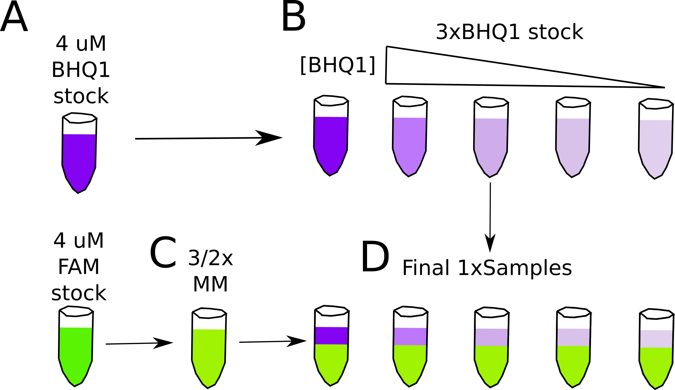

SI Figure 3 Sample preparation for fluorescence-detected binding isotherm analysis of RNA helix folding energies. Errors in the determination of concentrations of RNA stocks are systematically propagated during sample prep for fluorescence-detected isotherm experiments. **(A)** FAM-RNA and RNA-BHQ1 stock concentrations are determined at low μM concentrations with UV-absorbance. In this work, FAM and BHQ1 stocks were prepared at the same concentration of 4 μM. **(B)** RNA-BHQ1 stocks are diluted to a 3x concentration from one stock. **(C)** FAM-RNA stocks were diluted to a 3/2x concentration into artificial cytoplasm to make a master mix (MM). **(D)** One volume of 3x RNA-BHQ1 stock is mixed with two volumes of 3/2x MM to prepare the final solution. Solutions are layered in D to emphasize dilution, but they are mixed to form a homogeneous solution.

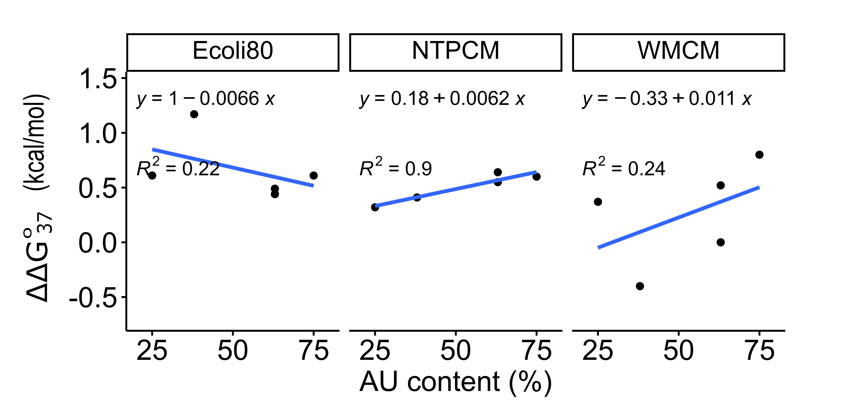

SI Figure 4 Helix destabilization by artificial cytoplasm in comparison to the 2 mM free Mg2+ condition to give DDGo37 versus AU content.

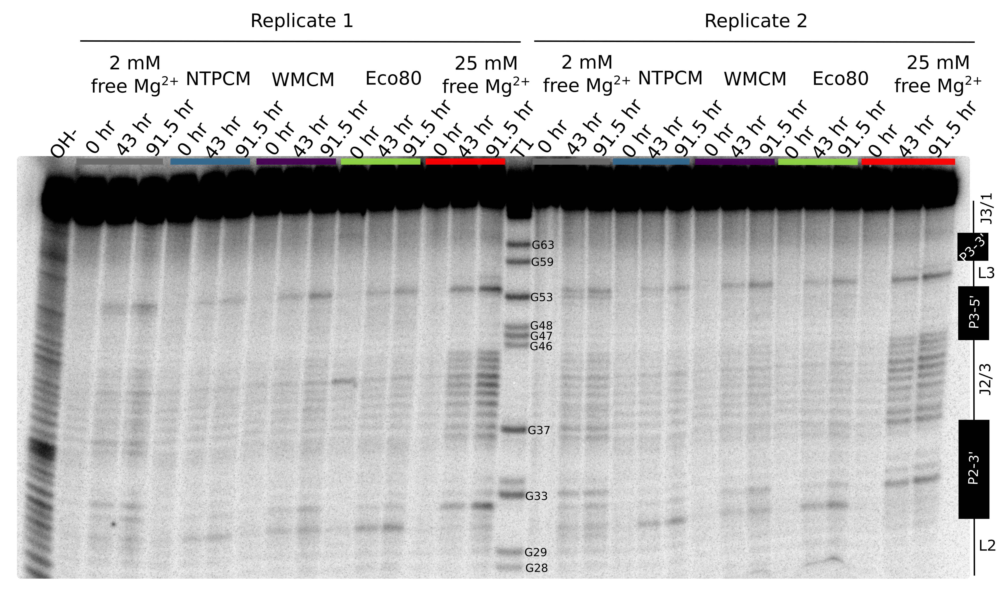

SI Figure 5 Raw ILP gel image for the guanine riboswitch aptamer incubated in artificial cytoplasms at 37 °C and pH 7. The OH- lane contains a hydrolysis ladder, which cleaves after every nucleotide, and a denaturing T1 contains the RNA treated with T1 ribonuclease, which cleaves after every unfolded G residue. Enough Mg2+ was added to each artificial cytoplasm to have 2 mM free Mg2+, as determined in Table 2. Nucleotides 28 to 63 were quantified. Cleavage fragments shorter than 28 could not be quantified because of band smearing due to the high concentration of charged molecules in the samples, and cleavage fragments longer than 63 were not resolved.

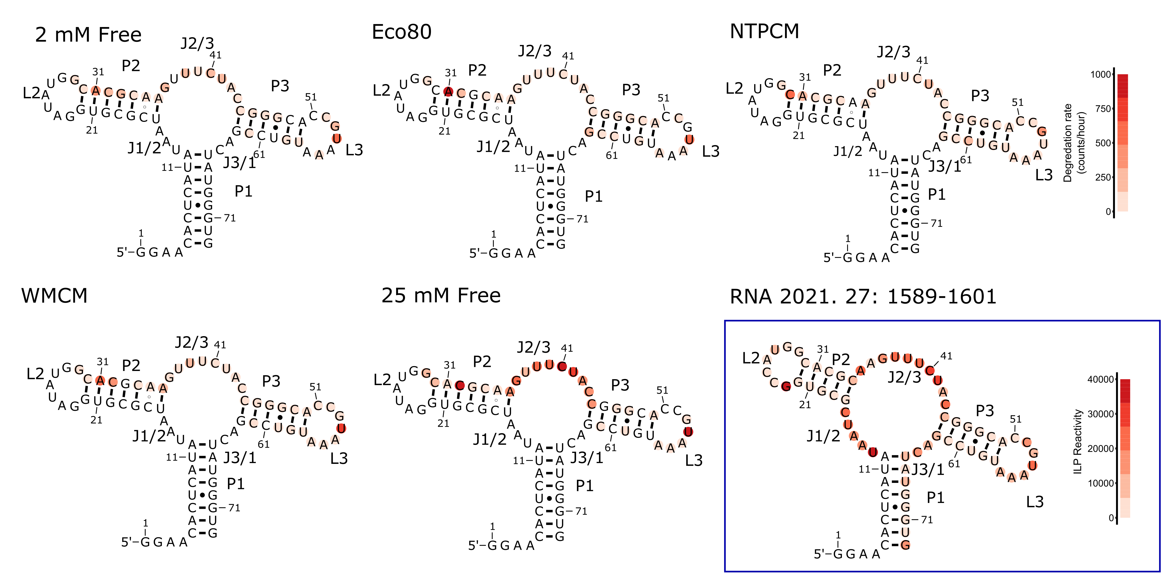

SI Figure 6 In-line degradation rates mapped onto the secondary structure of the guanine riboswitch. ILP data for the final diagram was adapted from the literature15 and is associated with a separate legend from degradation rates collected in this work.



SI Figure 7 Small angle x-ray scattering (SAXS) indicates that the guanine riboswitch aptamer adopts a similar structure in 2 mM free Mg2+, Eco80, NTPCM, WMCM and 25 mM free Mg2+. **(A)** Kratky scattering curves generated by the guanine aptamer in artificial cytoplasm. **(B)** P(r) plots generated with GNOM for the guanine riboswitch aptamer in artificial cytoplasm. The peak of the P(r) distribution is the radius of gyration (Rg) and the x-intercept at long distances is the Dmax.. **(C-G)** *Ab-initio* shape reconstructions overlayed on the crystal structure of the guanine aptamer (PDB 4FE5) with a solvent shell modeled with WAXSiS. Electron density maps were generated with DENSS and bead models were generated with the ATSAS package.

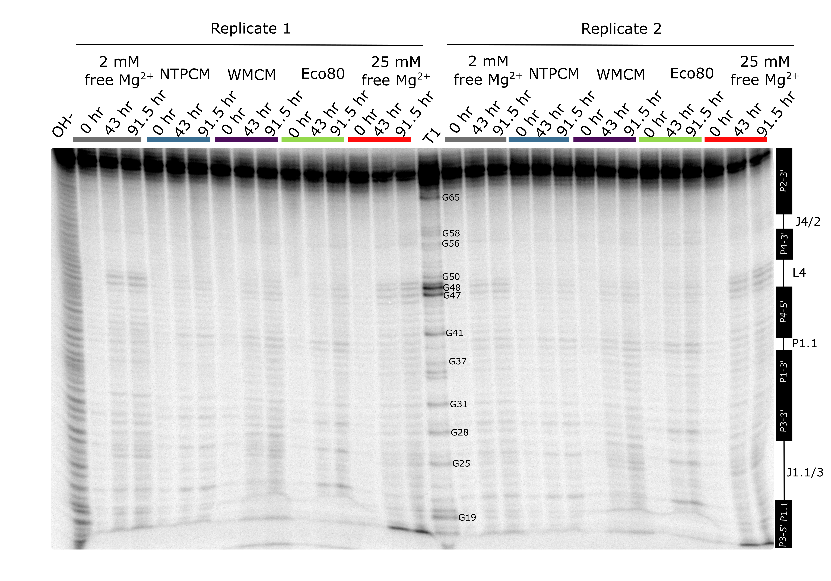

SI Figure 8 Raw ILP gel image for the cleaved CPEB3 ribozyme incubated in artificial cytoplasms at 37 °C and pH 7. The OH- lane contains a hydrolysis ladder which cleaves after every nucleotide, and a denaturing T1 contains the RNA treated with T1 ribonuclease, which cleaves after every unstructured G. Enough Mg2+ was added to each artificial cytoplasm to have 2 mM Mg2+  free as determined in Table 2. Nucleotides 22 to 56 were quantified. Cleavage fragments shorter than 22 could not be quantified because of band smearing due to the high concentration of charged molecules in the samples and cleavage fragments longer than 56 could not be resolved.

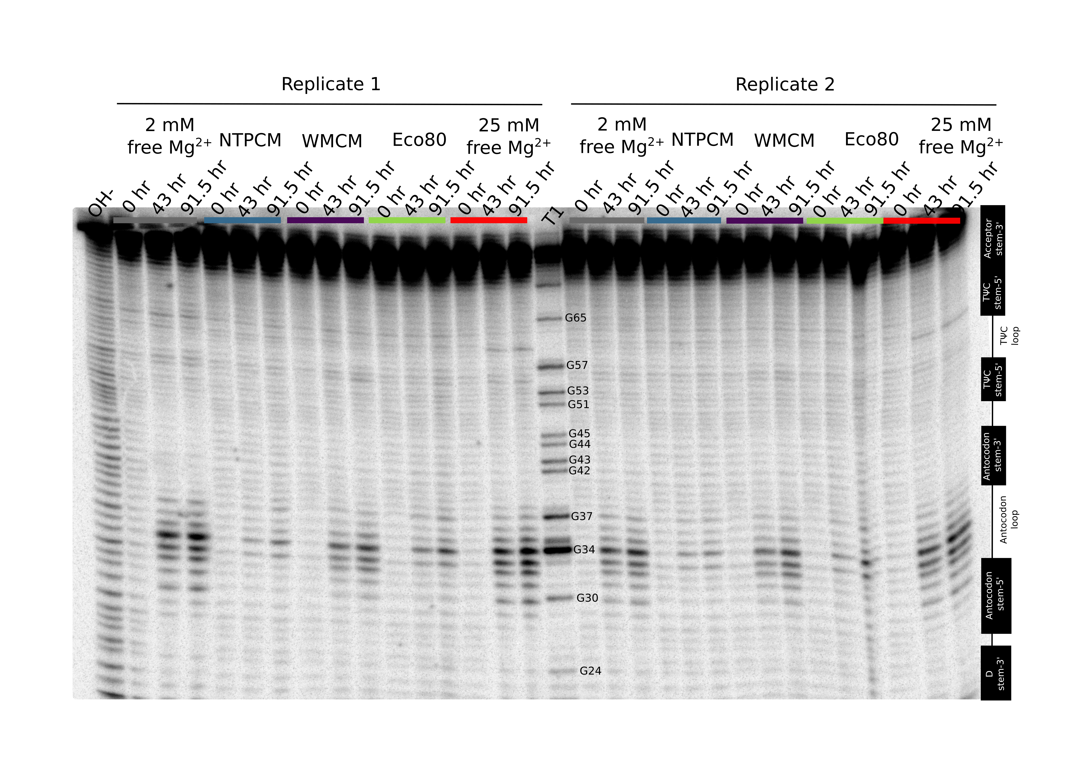

SI Figure 9 Raw ILP gel image for yeast tRNAphe incubated in artificial cytoplasms at 37 °C and pH 7 The OH- lane contains a hydrolysis ladder which cleaves after every nucleotide, and a denaturing T1 contains the RNA treated with T1 ribonuclease, which cleaves after every unstructured G. Enough Mg2+ was added to each artificial cytoplasm to have 2 mM Mg2+ free as determined in Table 2. Nucleotides 24 to 65 were quantified. Cleavage fragments shorter than 24 could not be quantified because of band smearing due to the high concentration of charged molecules in the samples and cleavage fragments longer than 65 could not be resolved.

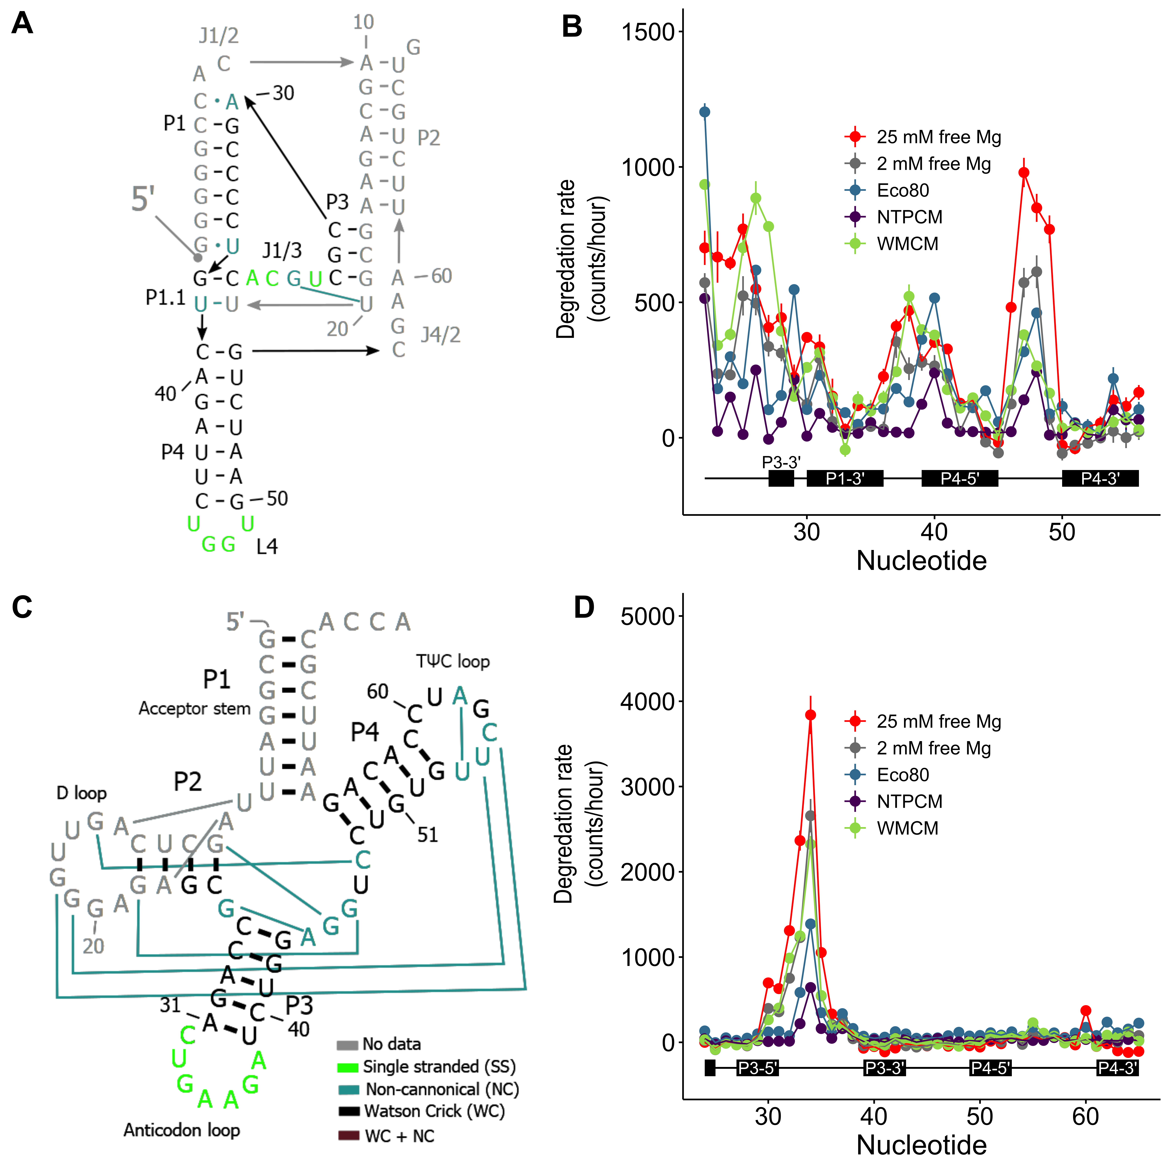

SI Figure 10 Eco80 and Mg2+-metabolite mixtures stabilize the chemical structure of RNA. **(A)** Secondary structure of the cleaved CPEB3 ribozyme with tertiary contacts represented by colored lines. **(B)** Degradation rate, by the increase in counts with time at each residue, in different solution conditions as a function of location in the cleaved CPEB3 ribozyme. Points represent the slope for the line of best fit of counts versus time, and error bars represent the standard error in the slope estimated from the fit. **(C)** Secondary structure of yeast tRNAphe with tertiary contacts represented by colored lines. **(D)** Degradation rate, by the increase in counts with time at each residue, in different solution conditions as a function of location in the tRNAphe . Points represent the slope for the line of best fit of counts versus time, and error bars represent the standard error in the slope estimated from the fit.

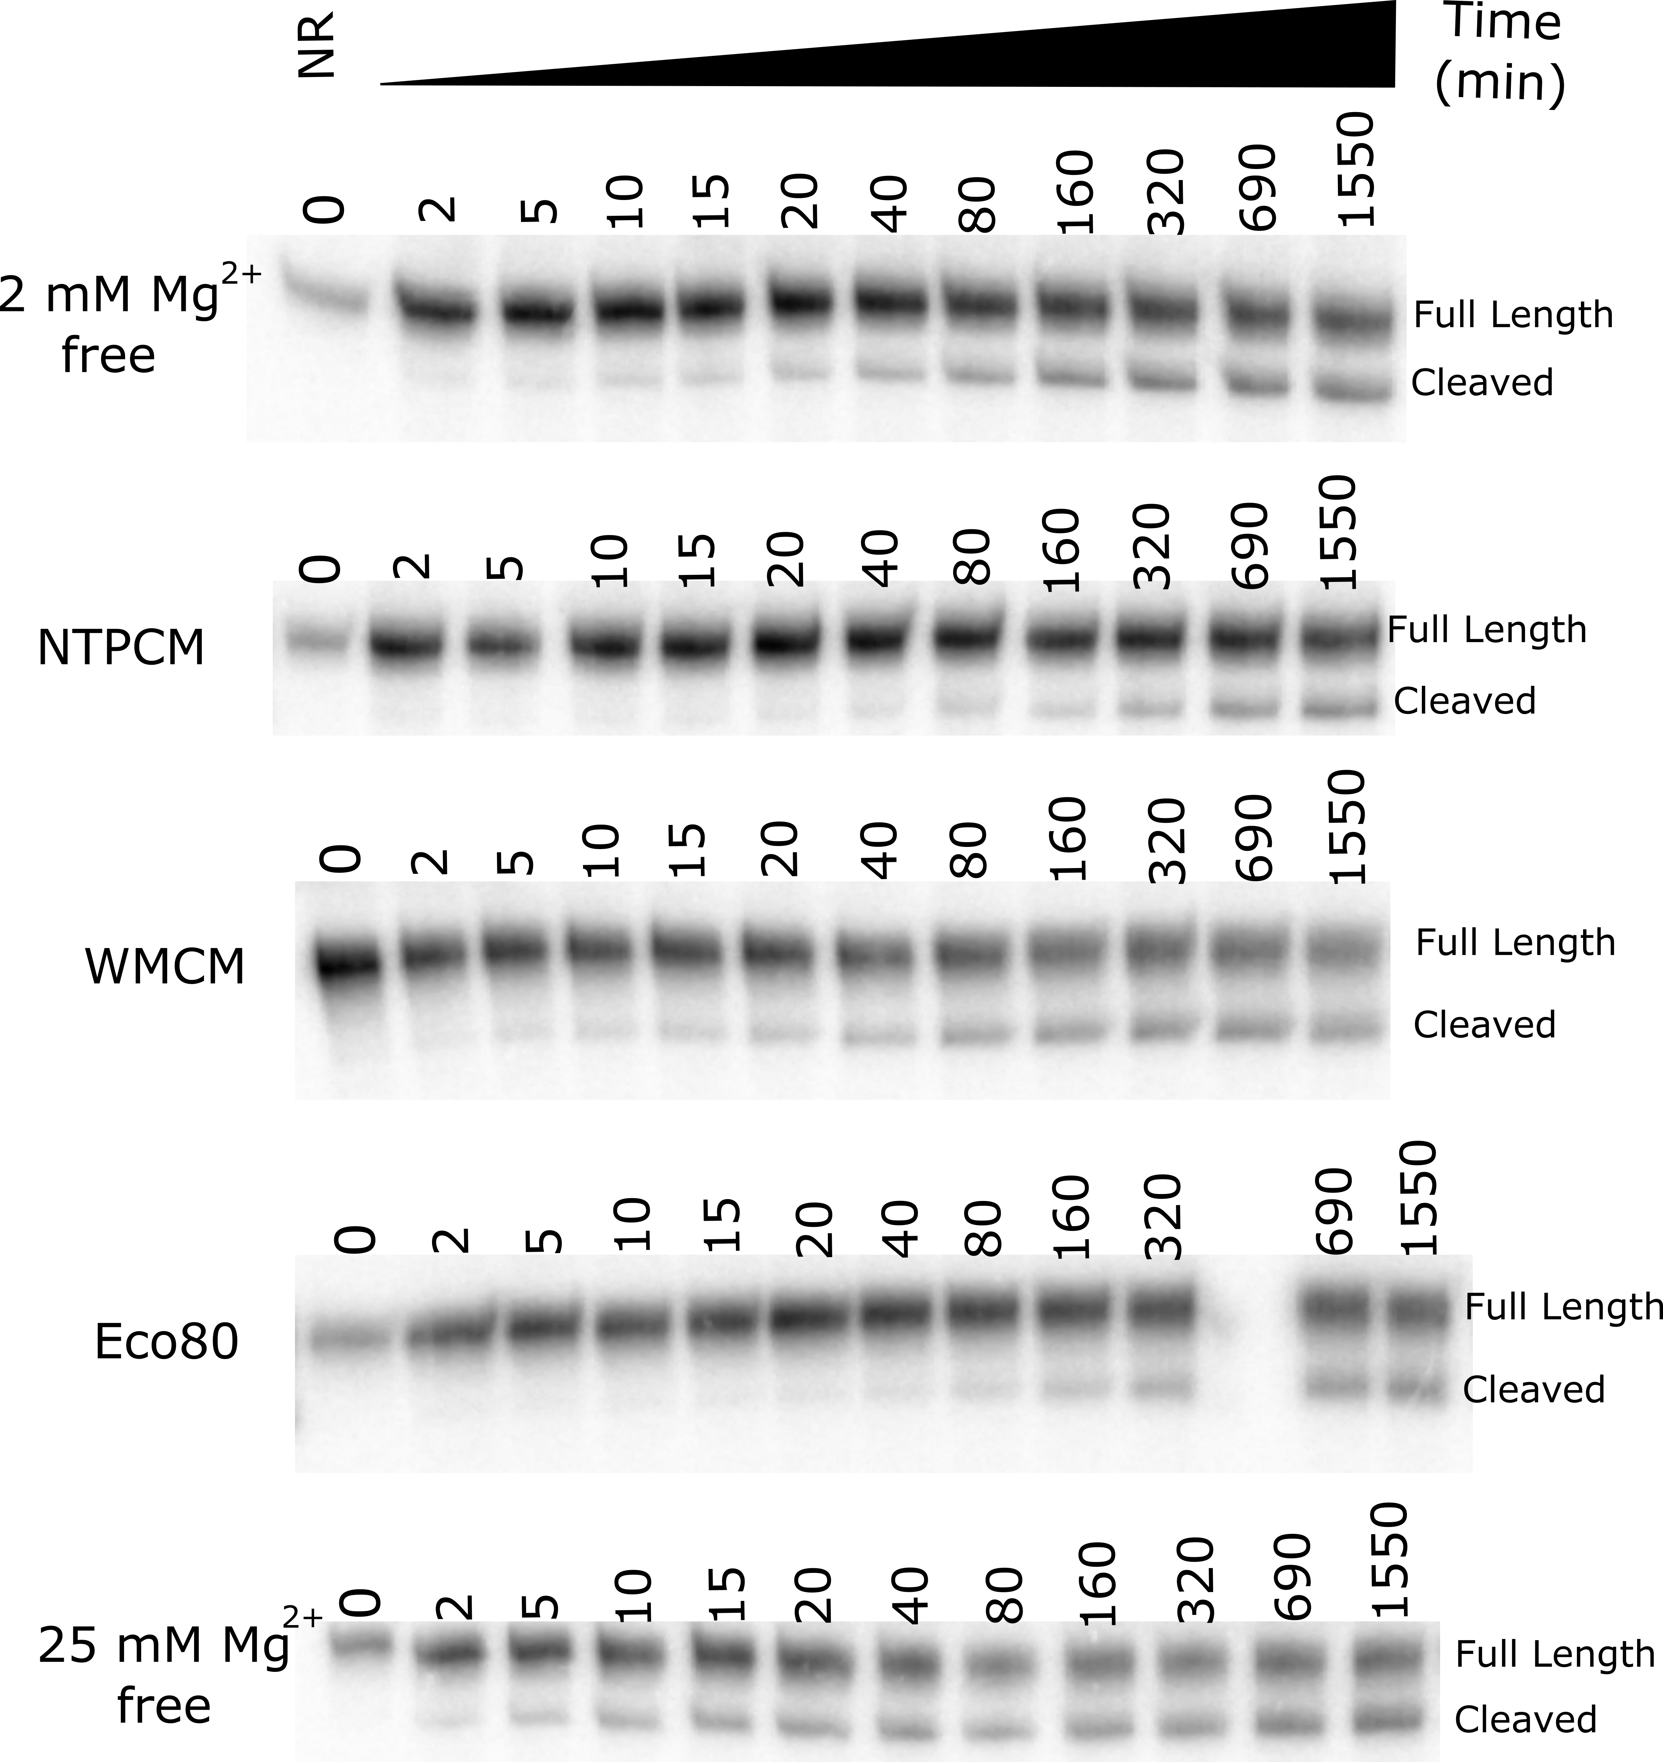

SI Figure 11 Body-labeled CPEB3 ribozyme kinetics denaturing polyacrylamide gel images. The electromobility of the short, 5´-cleaved band, was smeared by the high concentration of metabolites in the samples.



SI Figure 12 The concentration optimization algorithm improves the accuracy of helix folding energies calculated with MeltR using data with inaccurate RNA concentration estimates. **(A)** Error in the Gibbs free energy (ΔG°37) calculated with MeltR on modeled data assuming perfectly accurate RNA concentration estimates is reduced when the %FAM-RNA concentration error and %RNA-BHQ1 concentration error compensates according to the black line, %FAM-RNA error = %RNA-BHQ1. Data were modeled assuming an association enthalpy (ΔH°), entropy (ΔS°), and Gibb’s free energy at 37 °C (ΔG°37) of -56.2 kcal/mol, -136. 4 cal/mol/K, and -13.9 kcal/mol respectively, and 5% random fluorescence error. Concentration errors were seeded into the modeled data and the data was fit with MeltR. **(B)** Error in the Gibbs free energy (ΔG°37) calculated with MeltR on modeled data, assuming a +20% FAM-RNA concentration estimate error, is reduced when the %FAM-RNA concentration error and %RNA-BHQ1 concentration error compensate according to the red line, %RNA-BHQ1 = X*%FAM-RNA error + (100% – 100%*X)/X, where X is the factor the MeltR concentration optimization algorithm multiplies the FAM-RNA concentration estimate by. Data was modeled assuming an association ΔH°, ΔS°, and ΔG°37 of -56.2 kcal/mol, -136. 4 cal/mol/K, and -13.9 kcal/mol respectively, 5% random fluorescence error, and a +20% increase in the FAM-RNA concentration. Additional concentration errors were seeded into the modeled data and the data was fit with MeltR. **(C)** MeltR identifies the FAM-RNA concentration correction factor (X) using a low temperature fluorescence-detected isotherm as a Job plot. Black data points represent modeled fluorescence data from B at 20 °C. The black line represents the shape of the curve with a X of 1. The red line represents the shape of the curve with an optimized X of 1.2. **(D)** Error in the ΔG°37 calculated with MeltR using the concentration optimization algorithm and the data from B. On average, MeltR estimates the correct ΔG°37 within 0.2 kcal/mol, using the concentration optimization algorithm.



SI Figure 13 KDs calculated using MeltR are most accurate between the FAM-RNA concentration divided by 10 and 10 times the FAM-RNA concentration. At KDs that are more than 10 fold lower than the FAM-RNA concentration, the shape of the curve is independent of the KD. At KDs more than 10 fold higher than the FAM-RNA concentration, there is very little dependence of FAM-RNA emission on RNA-BHQ1 concentration. However, the curve shape is highly dependent on KD within the optimum range, so MeltR allows the user to specify an optimum KD range to calculate helix folding energies.

# Supplementary information tables

SI Table 1 Protocol for a 2x stock solution of the Eco80 artificial cytoplasm. Prepared in a 10 mL volumetric flask.

|  |  |  |  |  |  |  |  |
| --- | --- | --- | --- | --- | --- | --- | --- |
| **Step 1 mass reagents into a 10 mL volumetric flask** | | | | | | | |
| Reagent | Vendor (product #) | Purity | Molar mass (g/mL) | 2x[Ligand] (mM) | Mass or volume | Na+ added (mM) | K+ added  (mM) | |
| Adenine triphoshate  disodium salt hydrate | Sigma-Aldrich A2383 | ≥99% | 551.14 | 19.26 | 525 μL of 367 mM | 38.52 |  | |
| Uridine triphoshate  trisodium salt | Alpha-Azar J63427 | ≥98% | 550.09 | 16.58 | 448 μL of 370 mM | 49.74 |  | |
| Guanosine triphoshate   trisodium salt | Sigma-Aldrich G8877 | ≥95% | 523.18 | 9.74 | 380 μL of 256 mM | 29.22 |  | |
| Deoxythymidine triphoshate disodium salt | Thermo R0171 | ≥99% | solution | 9.24 | 924 μL of 100 mM | 18.48 |  | |
| L-glutamic acid potassium salt monohydrate | Millipore Sigma G1501 | ≥99% | 203.23 | 192 | 0.3902 g |  | 192 | |
| Glutathione, reduced, free acid | Cal biochem 3541 | ≥98% | 307.32 | 33.2 | 0.102 g |  |  | |
| D-Fructose-1,6-bisphosphate  trisodium salt hydrate | Sigma-Aldrich F6803 | ≥98% | 406.06 | 30.4 | 217 μL of 1400 mM | 91.2 |  | |
| Uridine 5'-diphospho-N-acetylglucosamine  disodium salt | Sigma-Aldrich U4375 | ≥98% | 651.32 | 18.48 | 313 μL of 591 mM | 36.96 |  | |
| D-Glucose 6-phosphate dipotassium salt hydrate | Sigma-Aldrich G7375 | ≥98% | 336.32 | 15.76 | 157 μL of 1001 mM |  | 31.52 | |
| L-aspartic acid  dipotassium salt | Millipore Sigma A9256 | ≥98% | 133.10 | 8.46 | 66 μL of 1276 mM |  | 16.92 | |
| L-valine monopotassium salt | Sigma Aldrich V0500 | ≥98% | 117.15 | 8.04 | 80 μL of 1000 mM |  | 16.08 | |
| L-glutamine monopotassium salt | Sigma G3126 | ≥99% | 146.14 | 7.62 | 43 μL of 1759 mM |  | 7.62 | |
| 6-Phosphogluconic acid trisodium salt | Sigma-Aldrich P6888 | ≥95% | 342.08 | 7.54 | 90 μL of 839 mM | 22.62 |  | |
| Sodium pyruvate | Sigma P8574 | ≥99% | 110.04 | 7.32 | 121 μL of 606 mM | 7.32 |  | |
| dihydroxyacetone phosphate hemi magnesium salt | Sigma 51296 | ≥95% | 180.19 | 6.12 | 54 μL of 1128 mM |  |  | |
| MOPS | Sigma-Aldrich  M3183 | ≥99.5 | 209.26 | 20 | 41.9 g |  |  | |
| EDTA | IBI scientific IB70182 | ≥99% | 372.24 | 0.01 | 1 μL of 100 mM  tetrasodium solution | 0.04 |  | |
| SDS | JT Baker  4095-04 | ≥99% | 288.38 | 0.035 (0.001%) | 10 μL of 35 mM  (1%) | 0.035 |  | |
| **Step 2 Add acid or base to to pH 7.0** | | | | | | | |
| Reagent | Vendor (product #) | Purity | Molar mass (g/mL) | 2x[Ligand] (mM) | Mass or volume | Na+ added (mM) | K+ added  (mM) | |
| Sodium hydroxide | Millipore Sigma  Sx0593 | ≥97% | 40.00 | NA | 100 μL of 10 M | 100 |  | |
| **Step 3 Calculate how much Na+ and K+ was added** | | | | | | | |
| Sum | | | | | | Na+ (mM) | K+ (mM) | |
| Total monovalent added (mM) | | | | | | 394.135 | 264.14 | |
| **Step 4 Add NaCl and KCl for a total final monovalent concentration of 480 mM Na+ and 280 mM K+** | | | | | | | |
| Reagent | Vendor (product #) | Purity | Molar mass (g/mL) | 2x[Ligand] (mM) | Mass or volume | Na+ added (mM) | K+ added  (mM) | |
| Sodium chloride | Dot Scientific DSS23020 | ≥99% | 58.4 |  | 171.7 μL of 5 M | 85.865 |  | |
| Potassium chloride | Millipore Sigma  P9541 | ≥99% | 74.55 |  | 79.3 μL of 2 M |  | 15.86 | |
| **Step 5 Fill to 10 mL in a volumetric flask and 2 µm filter** | | | | | | | |
| **Step 6 Check 1xConcentrated pH** | | | | | | | |
| Final pH | | | | | | | 6.99 | |

SI Table 2 Apparent binding constants determined with Isothermal titration calorimetry (ITC).

|  |  |  |  |  |  |
| --- | --- | --- | --- | --- | --- |
| Metabolite | Syringe  (mM) | Cell (mM) | ΔH (kcal/mol) | K’ (M-1) | KD’ (m M) |
| ATP | 15 mM MgCl2a | 0.1 mM ATPa | 1.83 (0.04) | 3600 (200) | 0.28 (0.01) |
| UTP | 15 mM MgCl2a | 0.2 mM UTPa | 1.70 (0.01) | 4200 (70) | 0.248 (0.004) |
| GTP | 15 mM MgCl2a | 0.2 mM GTPa | 1.43 (0.02) | 5000 (200) | 0.201 (0.007) |
| dTTP | 15 mM MgCl2a | 0.2 mM dTTPa | 2.19 (0.02) | 6300 (300) | 0.160 (0.003) |
| Fructose 1,6-BP | 100 mM MgCl2a | 5.0 mM Fructose 1,6-BPa | 0.414 (0.004) | 169 (4) | 5.9 (0.1) |
| UDP-GlcNAC | 100 mM MgCl2a | 5.0 mM UDP-GlcNAC | 0.57 (0.02) | 34 (2) | 29 (2) |
| Glucose 6-P | 100 mM MgCl2a | 5.0 mM Glucose 6-Pa | 0.555 (0.003) | 57.9 (0.7) | 17.3 (0.2) |
| 6-P-gluconic acid | 100 mM MgCl2a | 5.0 mM 6-P-gluconic acida | 0.662 (0.005) | 70 (1) | 14.4 (0.2) |
| Dihydroxyacetone phosphate | 100 mM MgCl2a | 5.0 mM dihydroxy-acetone phosphatea | 0.50 (0.01) | 51 (3) | 20 (1) |
| EDTA | 6 mM MgCl2a | 1.5 mM EDTA 1.0 mM MgCl2a,b | 2.85 (0.04) | 220,000 (30,000) | 0.0045 (0.0006) |

aIn 240 mM NaCl, 140 mM KCl ,10 mM HEPES (pH 7.0) at 37 °C bMg2+ and EDTA were incorporated into the cell in order to sequester trace tight binding metal ions and thereby negate their contribution to ITC signal.

SI Table 3Apparent metabolite-Mg2+ binding constants determined with HQS emission.

|  |  |  |  |  |  |
| --- | --- | --- | --- | --- | --- |
| Metabolite | Fmaxa | Fmina | KHQS (mM-1) a | K’ (mM-1)b | KD’ (mM-1)b |
| L-Glutamic acid | 187,000 (1000) | 0 (810) | 0.281 (0.008) | 0.0019 (0.0002) | 520 (50) |
| Glutathione | 182,000 (1000) | 592 (750) | 0.279 (0.007) | NAc | NAc |
| L-Aspartic acid | 196,000 (1000) | 0 (820) | 0.283 (0.007) | 0.0021 (0.0001) | 465 (12) |
| L-Valine | 188,200 (800) | 495 (580) | 0.274 (0.005) | NAc | NAc |
| L-Glutamine | 190,000 (1400) | 516 (110) | 0.27 (0.01) | NAc | NAc |
| Pyruvic acid | 188,000 (1500) | 0 (1300) | 0.35 (0.01) | 0.063 (0.003) | 15.8 (0.9) |

aFmax, Fmin, and KHQS are determined by fitting HQS emission in the absence of chelators and used to calculate the free Mg2+ concentration in each sample.

bMetabolite binding constants, K´ and KD´ are determined by fitting the relationship between the free Mg2+ concentration and the total MgCl2 concentration using SI Equation 4.

SI Table 4HQS fits in the absence of chelators.

|  |  |  |  |
| --- | --- | --- | --- |
| Artificial cytoplasm | Fmaxa | Fmina | KHQS (mM-1) a |
| Eco80 | 185,100 (800) | 124 (1000) | 0.239 (0.005) |
| NTPCM | 187,000 (1500) | 436 (1000) | 0.26 (0.01) |
| WMCM | 179,000 (1600) | 0 (1400) | 0.32 (0.01) |

aUsed to determine free Mg2+ concentrations in artificial cytoplasm. Fmax, Fmin, and KHQS are determined by fitting HQS emission in the absence of chelators and used to calculate the free Mg2+ concentration in each sample

SI Table 5Stability of RNA helices in *E. coli* metabolite mixtures.

|  |  |  |  |  |  |  |  |  |  |  |  |
| --- | --- | --- | --- | --- | --- | --- | --- | --- | --- | --- | --- |
| Sequencea | Conditionb | Xe | Method 1 VH plot  ΔHo  (kcal/mol) | Method 1 VH plot  ΔSo (cal/mol/K) | Method 1 VH plot  ΔGo37 (kcal/mol) | Method 2 Global fit  ΔHo (kcal/mol) | Method 2 Global fit  ΔSo (cal/mol/K) | Method 2 Global fit ΔGo37(kcal/mol) | %Diff.d  ΔHo | %Diff.d  ΔSo | %Diff.d  ΔGo37 |
| 1:  5´CGGAUGGC3´ 3´GCCUACCG5´ | Background | 1.1 | -71.13 (0.79) | -179.03 (2.36) | -15.60 (0.06) | -71.33 (11.41) | -179.61 (46.62) | -15.62 (1.19) | 0.28% | 0.37% | 0.10% |
| Eco80 | 1.0 | -69.65 (0.85) | -176.23 (2.54) | -14.99 (0.06) | -69.68 (12.22) | -176.31 (34.22) | -15.00 (0.80) | 0.04% | 0.04% | 0.02% |
| NTPCM | 1.2 | -70.37 (0.65) | -177.63 (1.94) | -15.28 (0.05) | -70.48 (15.64) | -177.97 (45.23) | -15.29 (1.08) | 0.16% | 0.19% | 0.05% |
| WMCM | 1.1 | -65.51 (2.41) | -162.09 (7.19) | -15.23 (0.18) | -65.35 (15.11) | -161.62 (36.43) | -15.23 (0.92) | 0.23% | 0.29% | 0.04% |
| 2:  5´CGCAUCCU3´ 3´GCGUAGGA5´ | Background | 1.3 | -56.25 (0.34) | -136.75 (1.04) | -13.42 (0.02) | -56.24 (18.32) | -136.70 (55.69) | -13.84 (1.05) | 0.03% | 0.03% | 0.01% |
| Eco80 | 1.5 | -43.78 (0.65) | -100.31 (2.00) | -12.67 (0.03) | -43.78 (8.16) | -100.31 (24.98) | -12.67 (0.41) | 0.01% | 0.01% | 0.01% |
| NTPCM | 2 | -52.17 (0.37) | -124.96 (1.13) | -13.41 (0.02) | -52.39 (7.58) | -125.62 (23.18) | -13.43 (0.39) | 0.04% | 0.53% | 0.09% |
| WMCM | 1.0 | -61.39 (0.76) | -152.07 (2.29) | -14.22 (0.05) | -61.12 (14.09) | -151.25 (42.53) | -14.21 (0.90) | 0.04% | 0.54% | 0.11% |
| 3:  5´CGUAUGUA3´ 3´GCAUACAU5´ | Background | 0.8 | -63.25 (0.94) | -168.94 (2.97) | -10.85 (0.02) | -62.27 (7.27) | -165.85 (23.02) | -10.84 (0.12) | 1.55% | 1.84% | 0.13% |
| Eco80 | 1.0 | -61.26 (1.07) | -163.94 (3.42) | -10.41 (0.01) | -60.95 (4.09) | -162.92 (13.09) | -10.41 (0.05) | 0.50% | 0.61% | 0.05% |
| NTPCM | 0.9 | -59.02 (1.16) | -157.11 (3.71) | -10.30 (0.01) | -58.52 (7.61) | -155.48 (24.33) | -10.29 (0.08) | 0.86% | 1.04% | 0.02% |
| WMCM | 1.0 | -66.97 (1.06) | -180.96 (3.36) | -10.85 (0.02) | -66.08 (10.50) | -178.11 (33.24) | -10.84 (0.20) | 1.35% | 1.59% | 0.14% |
| 4:  5´CCAUAUCA3´ 3´GGUAUAGU5´ | Background | 0.9 | -53.40 (0.97) | -133.39 (3.00) | -12.02 (0.04) | -52.28 (13.13) | -129.92 (41.09) | -12.00 (0.39) | 2.13% | 2.64% | 0.34% |
| Eco80 | 0.9 | -56.78 (1.54) | -146.36 (4.80) | -11.38 (0.05) | -54.03 (10.75) | -137.74 (33.27) | -11.30 (0.43) | 4.97% | 6.06% | 0.71% |
| NTPCM | 1.3 | -42.93 (0.46) | -101.31 (1.42) | -11.50 (0.02) | -42.39 (13.91) | -99.64 (43.16) | -11.48 (0.53) | 1.27% | 1.67% | 0.18% |
| WMCM | 1.0 | -42.99 (1.16) | -101.44 (3.58) | -11.53 (0.05) | -42.80 (20.42) | -100.86 (163.36) | -11.52 (0.78) | 0.44% | 0.58% | 0.06% |
| 5:  5´CCAUAUUA3´ 3´GGUAUAAU5´ | Background | 0.9 | -53.46 (0.37) | -137.65 (1.18) | -10.76 (0.01) | -53.17 (8.49) | -136.73 (27.11) | -10.76 (0.10) | 0.54% | 0.67% | 0.02% |
| Eco80 | 1.2 | -41.14 (0.26) | -99.91 (0.83) | -10.15 (0.01) | -41.05 (11.64) | -99.62 (37.42) | -10.15 (0.08) | 0.22% | 0.29% | 0.01% |
| NTPCM | 1.0 | -45.20 (0.19) | -113.00 (0.60) | -10.16 (0.01) | -45.08 (7.45) | -46.62 (23.92) | -10.16  (0.06) | 0.28% | 0.35% | 0.01% |
| WMCM | 0.8 | -43.16 (1.50) | -107.04 (4.79) | -9.96 (0.02) | -40.46 (9.27) | -98.41 (29.65) | -9.94 (0.09) | 6.46% | 8.41% | 0.22% |
| Average %error | | | 1.56% | 1.93% | 0.27% | 21.21% | 26.62% | 3.61% | 1.11% | 1.39% | 0.12% |

Helix energies were calculated by fitting fluorescence data with MeltR. Standard errors are estimated from fits. Extra significant digits are included to avoid propagating rounding errors.

aThe first sequence was 5’-FAM labeled and the second sequence was 3’-BHQ1 labeled.

bAll solutions contain 2 mM Free Mg, 240 Na+ 140 mM K+.

cConcentration optimization factor used to correct FAM-RNA concentrations by MeltR.

dPercent difference between Method 1 and Method 2.

SI Table 6 SAXS analysis

|  |  |  |  |  |  |  |
| --- | --- | --- | --- | --- | --- | --- |
| Condition | Guinier Rga (Å) | P(r) Rga (Å) | Dmaxa (Å) | Porod volumea (Å3) | DENSS  Rgb (Å) | DENSS resolutionb (Å) |
| Modelc | 19.7 (0.2) | 19.8 (0.1) | 69.8 | 35979 |  |  |
| 2 mM free | 24.5 (0.2) | 25.0 (0.2) | 69.4 | 42787 | 24.8 (0.2) | 31 (5) |
| Eco80 | 23.9 (0.4) | 23.4 (0.3) | 65.4 | 33212 | 22.9 (0.3) | 25 (4) |
| NTPCM | 24.5 (0.4) | 25.1 (1.0) | 70.2 | 54289 | 24.8 (0.1) | 15 (2) |
| WMCM | 26.9 (0.5) | 27.2 (0.4) | 82.1 | 26393 | 26.2 (0.4) | 27 (3) |
| 25 mM free | 27.1 (0.2) | 27.0 (0.2) | 75.0 | 47783 | 26.5 (0.3) | 34 (4) |

aDetermined with Primus in ATSAS.11

bDetermined from electron-density maps reconstructed using DENSS.12

cGenerated from the crystal structure (PDB 4FE5) of the guanine aptamer monomer using WAXSiS to account for scattering from the solvent shell.

SI Table 7 Structural classification of each nucleotide by manually inspecting crystal structures.

|  |  |  |  |  |  |  |  |  |  |  |  |
| --- | --- | --- | --- | --- | --- | --- | --- | --- | --- | --- | --- |
| Guanine riboswitch aptamer | | | | CPEB3 ribozyme | | | | tRNAphe | | | |
| N | | Classa | PDB | N | | Classa | PDB | N | | Classa | PDB |
| 29 | G | WC | PDB 4FE5: G38 | 22 | C | WC | PDB 3NKB: C23 | 24 | G | WC | PDB 1EHZ: G24 |
| 30 | C | WC | PDB 4FE5: C39 | 23 | A | SS | PDB 3NKB: U24 | 25 | C | WC | PDB 1EHZ: C25 |
| 31 | A | WC | PDB 4FE5: A40 | 24 | C | SS | PDB 3NKB: C25 | 26 | G | NC | PDB 1EHZ: G26 |
| 32 | C | WC | PDB 4FE5: C41 | 25 | G | NC | PDB 3NKB: G26 | 27 | C | WC | PDB 1EHZ: C27 |
| 33 | G | WC | PDB 4FE5: G42 | 26 | U | SS | PDB 3NKB: C27 | 28 | C | WC | PDB 1EHZ: C28 |
| 34 | C | WC | PDB 4FE5: C43 | 27 | C | WC | PDB 3NKB: G28 | 29 | A | WC | PDB 1EHZ: A29 |
| 35 | A | WC | PDB 4FE5: A44 | 28 | G | WC | PDB 3NKB: G29 | 30 | G | WC | PDB 1EHZ: G30 |
| 36 | A | WC | PDB 4FE5: A45 | 29 | C | WC | PDB 3NKB: C30 | 31 | A | WC | PDB 1EHZ: A31 |
| 37 | G | WC | PDB 4FE5: G46 | 30 | A | NC | PDB 3NKB: G31 | 32 | C | SS | PDB 1EHZ: C32 |
| 38 | U | SS | PDB 4FE5: U47 | 31 | G | WC | PDB 3NKB: C32 | 33 | U | SS | PDB 1EHZ: U33 |
| 39 | U | SS | PDB 4FE5: U48 | 32 | C | WC | PDB 3NKB: A33 | 34 | G | SS | PDB 1EHZ: G34 |
| 40 | U | NC | PDB 4FE5: U49 | 33 | C | WC | PDB 3NKB: A34 | 35 | A | SS | PDB 1EHZ: A35 |
| 41 | C | NC | PDB 4FE5: C50 | 34 | C | WC | PDB 3NKB: G35 | 36 | A | SS | PDB 1EHZ: A36 |
| 42 | U | SS | PDB 4FE5: U51 | 35 | C | WC | PDB 3NKB: C36 | 37 | G | SS | PDB 1EHZ: G37 |
| 43 | A | WC | PDB 4FE5: A52 | 36 | U | NC | PDB 3NKB: U37 | 38 | A | SS | PDB 1EHZ: A38 |
| 44 | C | WC | PDB 4FE5: C53 | 37 | G | WC | PDB 3NKB: G38 | 39 | U | WC | PDB 1EHZ: U39 |
| 45 | C | WC | PDB 4FE5: C54 | 38 | U | NC | PDB 3NKB: G39 | 40 | C | WC | PDB 1EHZ: C40 |
| 46 | G | WC | PDB 4FE5: G55 | 39 | C | WC | PDB 3NKB: A43 | 41 | U | WC | PDB 1EHZ: U41 |
| 47 | G | WC | PDB 4FE5: G56 | 40 | A | WC | PDB 3NKB: C44 | 42 | G | WC | PDB 1EHZ: G42 |
| 48 | G | WC | PDB 4FE5: G57 | 41 | G | WC | PDB 3NKB: A45 | 43 | G | WC | PDB 1EHZ: G43 |
| 49 | C | WC | PDB 4FE5: C58 | 42 | A | WC | PDB 3NKB: U46 | 44 | A | NC | PDB 1EHZ: A44 |
| 50 | A | WC | PDB 4FE5: A59 | 43 | U | WC | PDB 3NKB: U47 | 45 | G | NC | PDB 1EHZ: G45 |
| 51 | C | WC | PDB 4FE5: C60 | 44 | U | WC | PDB 3NKB: C48 | 46 | G | NC | PDB 1EHZ: G46 |
| 52 | C | WC | PDB 4FE5: C61 | 45 | C | WC | PDB 3NKB: C49 | 47 | U | SS | PDB 1EHZ: U47 |
| 53 | G | NC | PDB 4FE5: G62 | 46 | U | SS | PDB 3NKB: G50 | 48 | C | NC | PDB 1EHZ: C48 |
| 54 | U | NC | PDB 4FE5: U63 | 47 | G | SS | PDB 3NKB: A51 | 49 | C | WC | PDB 1EHZ: C49 |
| 55 | A | NC | PDB 4FE5: A64 | 48 | G | SS | PDB 3NKB: A52 | 50 | U | WC | PDB 1EHZ: U50 |
| 56 | A | NC | PDB 4FE5: A65 | 49 | U | SS | PDB 3NKB: A53 | 51 | G | WC | PDB 1EHZ: G51 |
| 57 | A | NC | PDB 4FE5: A66 | 50 | G | WC | PDB 3NKB: G54 | 52 | U | WC | PDB 1EHZ: U52 |
| 58 | U | WC | PDB 4FE5: U67 | 51 | A | WC | PDB 3NKB: G55 | 53 | G | WC | PDB 1EHZ: G53 |
| 59 | G | WC | PDB 4FE5: G68 | 52 | A | WC | PDB 3NKB: A57 | 54 | U | NC | PDB 1EHZ: U54 |
| 60 | U | WC | PDB 4FE5: U69 | 53 | U | WC | PDB 3NKB: A58 | 55 | U | NC | PDB 1EHZ: U55 |
| 61 | C | WC | PDB 4FE5: C70 | 54 | C | WC | PDB 3NKB: U59 | 56 | C | NC | PDB 1EHZ: C56 |
| 62 | C | WC | PDB 4FE5: C71 | 55 | U | WC | PDB 3NKB: G60 | 57 | G | SS | PDB 1EHZ: G57 |
| 63 | G | WC | PDB 4FE5: G72 | 56 | G | WC | PDB 3NKB: G61 | 58 | A | NC | PDB 1EHZ: A58 |
|  |  |  |  |  |  |  |  | 59 | U | SS | PDB 1EHZ: U59 |
|  |  |  |  |  |  |  |  | 60 | C | SS | PDB 1EHZ: C60 |
|  |  |  |  |  |  |  |  | 61 | C | WC | PDB 1EHZ: C61 |
|  |  |  |  |  |  |  |  | 62 | A | WC | PDB 1EHZ: A62 |
|  |  |  |  |  |  |  |  | 63 | C | WC | PDB 1EHZ: C63 |
|  |  |  |  |  |  |  |  | 64 | A | WC | PDB 1EHZ: A64 |
|  |  |  |  |  |  |  |  | 65 | G | WC | PDB 1EHZ: G65 |

aGroupings are based on analysis of crystal structures with PDB ID provided. SS: Single stranded, the base was not participating in hydrogen bonding interactions with other residues. NC: non-canonical, the base was forming non-canonical hydrogen bonding interactions in the tertiary structure. WC: Watson-Crick, the base was in a helix comprised mostly of Watson-Crick base pairs**.**

**SI Table 8** DNA sequences used for RNA transcription

|  |  |  |
| --- | --- | --- |
| RNA | Template type | DNA sequences |
| Guanine riboswitch aptamer | Primer extended duplex | Forward primer: 5´CGCGTAATACGACTCACTATAGGAACACTCATATAATCGCGTGGATATGGCACGCAAGTT3´  Reverse primer: 5´CACCCATAGTCGGACATTTACGGTGCCCGGTAGAAACTTGCGTGCCATATCCACGCGATT3´ |
| CPEB3 ribozyme | Primer  extended duplex | Forward primer: 5´GCGAAATTTAATACGACTCACTATAGGATCAAGGGGATAACAGGGGGCCACAGCAGAAGCGTTCACGTCGCAGCC3´  Reverse primer: 5´CAGCAGAATTCGCAGATTCACCAGAATCTGACAGGGGCTGCGACGTGAACGCTTCTG3´ |
| tRNAphe | Hemi- duplex | Forward primer: 5´TAATACGACTCACTATA3´  Template: 5´TGGTGCGAATTCTGTGGATCGAACACAGGACCTCCAGATCTTCAGTCTGGCGCTCTCCCAACTGAGCT AAATCCGCTATAGTGAGTCGTATTA3´ |

Supplementary References

(1) Weinberg, Z.; Breaker, R. R. R2R - Software to Speed the Depiction of Aesthetic Consensus RNA Secondary Structures. *BMC Bioinformatics* **2011**, *12* (1), 3. https://doi.org/10.1186/1471-2105-12-3.

(2) Yamagami, R.; Sieg, J. P.; Bevilacqua, P. C. Functional Roles of Chelated Magnesium Ions in RNA Folding and Function. *Biochemistry* **2021**, *60* (31), 2374–2386. https://doi.org/10.1021/acs.biochem.1c00012.

(3) Grilley, D.; Soto, A. M.; Draper, D. E. Chapter 3 Direct Quantitation of Mg2+‐RNA Interactions by Use of a Fluorescent Dye. In *Methods in Enzymology*; Biothermodynamics, Part A; Academic Press, 2009; Vol. 455, pp 71–94. https://doi.org/10.1016/S0076-6879(08)04203-1.

(4) Dulin, D.; Arnold, J. J.; van Laar, T.; Oh, H.-S.; Lee, C.; Perkins, A. L.; Harki, D. A.; Depken, M.; Cameron, C. E.; Dekker, N. H. Signatures of Nucleotide Analog Incorporation by an RNA-Dependent RNA Polymerase Revealed Using High-Throughput Magnetic Tweezers. *Cell Rep.* **2017**, *21* (4), 1063–1076. https://doi.org/10.1016/j.celrep.2017.10.005.

(5) Yamagami, R.; Bingaman, J. L.; Frankel, E. A.; Bevilacqua, P. C. Cellular Conditions of Weakly Chelated Magnesium Ions Strongly Promote RNA Stability and Catalysis. *Nat. Commun.* **2018**, *9* (1), 2149. https://doi.org/10.1038/s41467-018-04415-1.

(6) Xia, T.; SantaLucia, J.; Burkard, M. E.; Kierzek, R.; Schroeder, S. J.; Jiao, X.; Cox, C.; Turner, D. H. Thermodynamic Parameters for an Expanded Nearest-Neighbor Model for Formation of RNA Duplexes with Watson−Crick Base Pairs †. *Biochemistry* **1998**, *37* (42), 14719–14735. https://doi.org/10.1021/bi9809425.

(7) Fersht, A. *Enzyme Structure and Mechanism*; New York : W.H. Freeman, 1985.

(8) Leamy, K. A.; Yennawar, N. H.; Bevilacqua, P. C. Cooperative RNA Folding under Cellular Conditions Arises From Both Tertiary Structure Stabilization and Secondary Structure Destabilization. *Biochemistry* **2017**, *56* (27), 3422–3433. https://doi.org/10.1021/acs.biochem.7b00325.

(9) Mandal, M.; Boese, B.; Barrick, J. E.; Winkler, W. C.; Breaker, R. R. Riboswitches Control Fundamental Biochemical Pathways in Bacillus Subtilis and Other Bacteria. *Cell* **2003**, *113* (5), 577–586. https://doi.org/10.1016/S0092-8674(03)00391-X.

(10) Laederach, A.; Das, R.; Vicens, Q.; Pearlman, S. M.; Brenowitz, M.; Herschlag, D.; Altman, R. B. Semiautomated and Rapid Quantification of Nucleic Acid Footprinting and Structure Mapping Experiments. *Nat. Protoc.* **2008**, *3* (9), 1395–1401. https://doi.org/10.1038/nprot.2008.134.

(11) Petoukhov, M. V.; Franke, D.; Shkumatov, A. V.; Tria, G.; Kikhney, A. G.; Gajda, M.; Gorba, C.; Mertens, H. D. T.; Konarev, P. V.; Svergun, D. I. New Developments in the ATSAS Program Package for Small-Angle Scattering Data Analysis. *J. Appl. Crystallogr.* **2012**, *45* (Pt 2), 342–350. https://doi.org/10.1107/S0021889812007662.

(12) Grant, T. D. Ab Initio Electron Density Determination Directly from Solution Scattering Data. *Nat. Methods* **2018**, *15* (3), 191–193. https://doi.org/10.1038/nmeth.4581.

(13) Batey, R. T.; Gilbert, S. D.; Montange, R. K. Structure of a Natural Guanine-Responsive Riboswitch Complexed with the Metabolite Hypoxanthine. *Nature* **2004**, *432* (7015), 411. https://doi.org/10.1038/nature03037.

(14) Knight, C. J.; Hub, J. S. WAXSiS: A Web Server for the Calculation of SAXS/WAXS Curves Based on Explicit-Solvent Molecular Dynamics. *Nucleic Acids Res.* **2015**, *43* (W1), W225–W230. https://doi.org/10.1093/nar/gkv309.

(15) Poudyal, R. R.; Sieg, J. P.; Portz, B.; Keating, C. D.; Bevilacqua, P. C. RNA Sequence and Structure Control Assembly and Function of RNA Condensates. *RNA* **2021**, *27* (12), 1589–1601. https://doi.org/10.1261/rna.078875.121.